МИНИСТЕРСТВО ОБРАЗОВАНИЯ АРХАНГЕЛЬСКОЙ ОБЛАСТИ
государственное бюджетное профессиональное образовательное учреждение
Архангельской области «Архангельский государственный многопрофильный колледж»

ОГСЭ.03 Иностранный язык

ПРАКТИЧЕСКОЕ ЗАНЯТИЕ №3
tax accounting –
Налоги

1.Прочитайте текст. Устно его переведите.
Calvin Dean and Associates
We specialize in tax accounting. Our experienced accountants help you with all your tax accounting needs:
• Corporate tax
• Sales tax
• Property tax
• Excise tax
• Inheritance tax
• Value-added tax.
In addition to individual and corporate accounting, we also offer income tax preparation services. We assist you in filing out your tax forms. Then we will file them with the IRS at no additional charge. Call today to make an appointment.

1.1. Соотнесите слова с их определениями. Формат записи – цифра-буква

1 corporate tax | 2 property tax | 3 file | 4 sales tax | 5 inheritance tax

A money that businesses pay to a government
B money that is paid to a government after a person dies
C a fee that local governments charge owners of real estate
D a fee that governments charge when goods are sold
E to submit documents to a government agency

1.2. Заполните пропуски подходящими по смыслу словами из рамки. Формат записи – цифра-слово. Переведите предложения.

value-added tax | IRS | excise tax | specialize | tax forms

1. In addition to paying taxes, people also have to file _______ .
2. The________ is the U.S. agency in charge of taxation.
3. Accountants sometimes _______ in a certain type of accounting.
4. ___________is a fee for producing products like fuel and tobacco.
5. __________is charged at each step in the manufacturing process.

2. Прочитайте текст диалога. Рекомендуется прослушать его аудиозапись при наличии технической возможности. Устно переведите.

Chief Executive Officer (CEO) – We’ve got a few minutes to ourselves. Could you just go over it again? How is the taxation expense calculated?
Accountant – Ok. The operating profit minus our interest expenses gives us the profit before tax figure. This is the amount which theoretically is then subject to taxation. In fact, the taxation amount is just an estimate, because we won’t know until much later exactly how much tax we’ll have to pay.
CEO – What do we do with this estimate?
Accountant – In effect we prepare an interim tax return. It won’t be filled. Just keep by us to justify the taxation expense we include in the P&L.
CEO – Will this also be audited?
Accountant – Yes. And of course the profit after tax is the figure which we can distribute to shareholders.
CEO – What do we do when the taxable income differs from the profit before tax?
Accountant – We record what happens on the balance sheet. It’s either a net deferred tax or liability.

2.1. Ответьте по-английски на вопросы к тексту письменно. Вопросы запишите.

1) How does the accountant calculate the profit before tax figure?
2) Why is the taxation amount only an estimate?
3) Why do they need an interim tax return?

2.2. Заполните пропуски словами из текста диалога. Формат записи: цифра-буква. Переведите полученный текст.

Taxation expense is calculated by subtracting 1) ____________________________________________ from 2) ___________________________________ . This gives us an estimate, which we use to 3) _______
________________________________________ . We need it to justify 4) __________________________
__________ . If there is any difference between the profit before tax and the taxable income, we 5) ______
________________ .

3 Соотнесите слова с их определениями. Формат записи – цифра-буква.

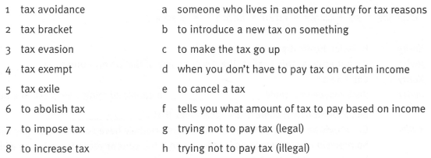

4. Заполните пропуски подходящими по смыслу словами из рамки. Формат записи – цифра-слово. Переведите предложения.
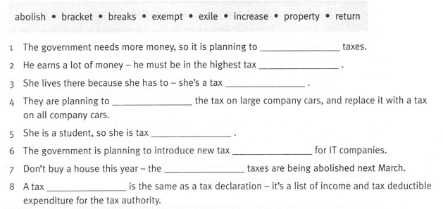
Преподаватель – Ирина Владимировна Комлева

