МИНИСТЕРСТВО ОБРАЗОВАНИЯ АРХАНГЕЛЬСКОЙ ОБЛАСТИ
государственное бюджетное профессиональное образовательное учреждение
Архангельской области «Архангельский государственный многопрофильный колледж»

ОГСЭ.03 Иностранный язык

ПРАКТИЧЕСКОЕ ЗАНЯТИЕ №4
AUDITING
Аудит

1.Прочитайте текст. Устно его переведите.
FROM: Patrick Stevens, Auditor, Thomas and Riley LLP
TO: Jack Riley, Thomas and Riley LLP
Mr. Riley,
I have completed my audit of Endless Magic Toy Company. Unfortunately, I cannot give a clean opinion of this company without material adjustments to the financial statements. I found a few anomalous entries in its books that should be attended to. First, I noticed that the reported sales figures do not match the actual revenue. At first, I thought it could have been a simple clerical error. But then I recalled something I had read earlier about bonuses for sales people. Sure enough, it appears the sales people reported erroneous sales figures - sales that won't actually occur until next quarter. I believe they did this in order to surpass the bonus cutoff point. The second impropriety that I found had to do with some new manufacturing equipment. As you know, these assets should have been capitalized and depreciated over their useful life. But someone chose to write the entire purchase price off as an expense. Any government tax department employee would see this immediately in an audit. I am surprised by the lack of professional skepticism on the part of Endless Magic Toy Company's internal auditor. I have a meeting with the Chief Operating Officer tomorrow, and I plan to discuss these issues with her.
Regards,
Patrick Stevens

  - Выберите правильный ответ. Формат записи – цифра-буква

1) What is the passage mainly about?
A the results of an audit
B how to make material adjustments
C the results of a meeting with the COO.
D problems with Thomas and Riley's books

2) What did Endless Magic's sales people do?
A They made a clerical error.
B They falsified sales information.
C They made material adjustments.
D They showed professional skepticism.

3) What did the company do when it purchased new equipment?
A It depreciated the equipment.
B It capitalized its old equipment.
C It wrote off the purchase as an expense.
D It got advice from a government employee.

  - Соотнесите слова с их определениями. Формат записи – цифра-буква

1 anomalous | 2 cutoff point | 3 chief operating officer | 4 impropriety | 5 professional skepticism

A a corporate executive in charge of operations
B the level that must be reached to receive some reward
C the critical attitude an auditor must have
D any activity that is unethical
E out of the ordinary

  - Заполните пропуски подходящими по смыслу словами из рамки. Формат записи – цифра-слово. Переведите предложения.

clean opinion | clerical error | erroneous | capitalized | material adjustments

1 It wasn't a deliberate falsification, just a(n) ____________ .
2 Depreciable assets should be ______________ .
3 The auditor gave the company a(n) ______________ because of its accurate records.
4 Ben was fired for recording ____________ sales figures.
5 They made ______________ to correct the incorrect entries.

- Прочитайте текст диалога. Рекомендуется прослушать его аудиозапись при наличии технической возможности. Устно переведите.

Claude – Claude Bernaud.
Janet – Hi, Claude, it’s Janet. You wanted to chat?
Claude – Hi, Janet. Great, you got my message. Thanks for getting back to me so quickly.
Janet – You’re welcome. How can I help?
Claude – Well, it’s about your preliminary report. There are a couple of things I think we need to discuss.
Janet – Yeah, sure. No problem. I have it in front of me.
Claude – Hang on. I just find my notes. OK. The first point is on page eleven, third paragraph. What do you mean exactly?
Janet – OK. Let’s have a look. Oh yes. Capitalization of costs in your factories. We think that these costs should be expenses in the P&L.
Claude – But… No sorry. I’m afraid, I disagree. They were necessary for the upgrade of our plant. Surely you agree that we have to keep up with the competition?
Janet – Yes, of course. But lots of the items we tested are clearly normal repair and maintenance expenses. You can’t really justify including such costs under machine upgrades.
Claude – I see it differently. Our machines have been developed to produce a wider variety of products, to improve the running efficiency of the equipment, to keep us in business. This was a sizeable investment on our part. The figure we are talking about shows the commitment, we’ve made to the future. I mean we’re going to be getting benefits from these upgrades for years. Our balance sheet should show this.
Janet – I’m sorry, these figures are too material for us to ignore. There are some expenses which…
Claude – Companies do this all the time and, I might add, their auditors accept it. I suggest you consider this again. I’m sure you’ll find it’s reasonable when you think about how important these investments were to this company.
Janet – All right. We’ll look at these costs again. Let’s move on the next point.

  - Верны (T) или неверны (F) данные утверждения согласно тексту.
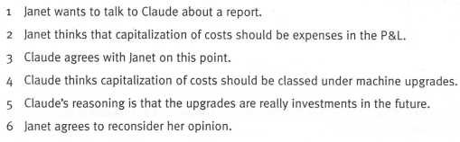

- К каждому предложению под цифрой даны два предложения под буквами справа, из которых необходимо выбрать наиболее подходящее по смыслу. Формат записи – цифра-буква.
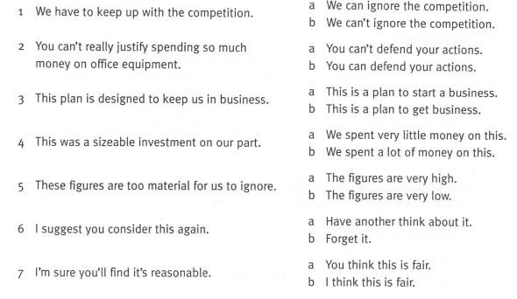

- Соотнесите графики с их описаниями. Формат записи – цифра-буква

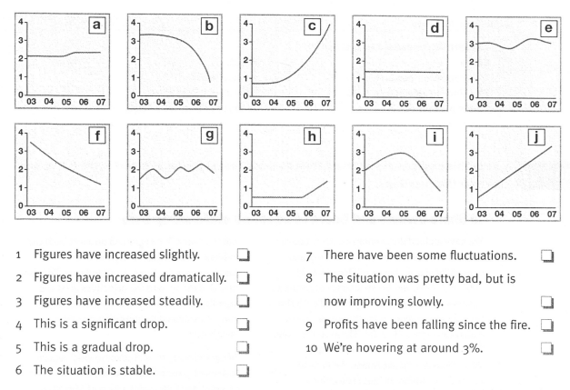
Преподаватель – Ирина Владимировна Комлева

